**MISSIOIN TO UGANDA**

**OUT REACH**

**TO NANSO B.**

**ON 22/11/2024**

**ST FRANCIS HOSPITAL NYENGA.**

**TAKEN PLACE AT NANSO B PRIMARY SCHOOL**

# **DEDICATIONS**

This report is dedicated to the vulnerable natives living in the RURAL areas of NABSO B village in Buikwe district.

**ACKNOWLEDGMENT**

Our gratitude goes to God who enabled us to successfully complete the outreach in Nanso B. We would also want to send our heartfelt thanks to Nyenga hospital administration and our partners for the support they did give us throughout the course of the activity. We worked as a team of several individuals and organizations including a team of health workers from Nyenga, VHTs, and partners of mission to Uganda to make it possible.

**Thankyou mission to Uganda.**

**TABLE OF CONTENTS**

Contents

**DEDICATIONS** ........................................................................................................................................ 1

**DEDICATIONS** 2

**ACTIVITIES** 5

**2.1 Arrival** 5

**2.2 Triage** 5

**2.3 Clinical assessment** 5

**2.4 Laboratory** 5

**2.5 Mother Child Health services** 5

**2.6 Dispensary** 6

**FINDINGS** 8

**3.1 A table showing the demographic data of patients seen during the outreach** 8

**3.2 A table below showing statistical data of the conditions managed during the outreach.** 8

**DISCUSIONS** 9

**CHALLENGES, RECOMENDTIONS AND CONCLUSIONS** 11

**4.1 Challenges** 11

**4.2 Recommendations** 11

**ABBREVIATIONS**

**ACT:** Artemisinin-based Combination Therapy

**ANC:** Antenatal Care

**H/C:**  Health Center

**HIV:** Human Immunodeficiency Virus

**NCDs:** Non-communicable diseases

**PUD:** Peptic Ulcer Disease

**RBS**: Random Blood Sugar

**RDT:** Rapid diagnostic test

**SSA**: Sub-Saharan Africa

**UNEPI:** Uganda National Expanded Program on Immunization

**VHT:**  Village Health Team

**WHO:** World Health Organization

**NOK:** Next Of Kin

**PREP:** Pre-Exposure Prophylaxis

**ACTIVITIES**

**2.1 Arrival**

Early in the morning on the 22th / 11/ 24 At about 8:30am, the team from Nyenga hospital arrived started and setting up tents and working stations.

**2.2 Triage**

A triaging station was in place under one of the tents where all natives where given numbers, registered, weighed and blood pressures where taken. This work was carried out by 3 staff nurses. Patients were sent to a waiting area.

**A HEALTH EDUCATION** was offered to all on malaria prevention, dental health and oral hygiene to reduce on dental caries. TB prevention and on how to cough

**2.3 Clinical assessment**

In one of the school classrooms. Here the clinical team picked history, examined, sent for investigations and prescribed medication for patients who were presumed for TB had sputum taken for investigation

**2.4 Laboratory**

The temporary lab was set up under the mango tree and was managed by two staffs. They did ran MALARIA, RDTs, RBS and urinalysis.

**2.5 Mother Child Health services**

These involved immunization and antenatal care service and were given to children due and expecting mothers. All recommended vaccines were carried using the cold chain system as they were in a carrier and were administered according to the WHO immunization schedule. Mothers too had obstetric examination, received tetanus shorts, folic and iron supplements. These mothers also were also given malaria preventive treatment.

**2.6 Dispensary**

Run by 3 staffs, the dispensing station. Several drugs where dispensed following prescription from the clinical team. They also did explain to the patients how the medication should be taken.

**FINDINGS**

**3.1 A table showing the demographic data of patients seen during the outreach**

|  |  |  |  |  |
| --- | --- | --- | --- | --- |
| **Age group** | **Female** | **Male** | **Total** | **Percentage** |
| 0-9 | 31 | 23 | 54 | 44.6 |
| 10-19 | 09 | 13 | 22 | 18.1 |
| 20-29 | 14 | 02 | 16 | 13.2 |
| 30-39 | 09 | 03 | 12 | 9.9 |
| 40-49 | 04 | 02 | 06 | 4.9 |
| 50+ | 08 | 03 | 11 | 9 |
| **GENDA** | **FEMALE 75** | | | 61.9 |
|  |
| **MALE 46** | | | 38 |
|  |

# **3.2 A table below showing statistical data of the conditions managed during the outreach.**

|  |  |  |
| --- | --- | --- |
| **Condition** | **Number of patients** | **Percentage (%)** |
| Respiratory tract infections | 49 | 40 |
| Malaria | 22 | 18 |
| Urinary tract infections | 06 | 4.9 |
| Skin conditions | 14 | 11.5 |
| Peptic ulcer disease | 4 | 3.3 |
| Hypertension | 3 | 2.4 |
| Diarrheal diseases | 16 | 13.2 |
| Eye conditions | 5 | 4.1 |
| Diabetes mellitus | 1 | 0.8 |
| Others | 21 | 17.3 |
| ANC | 3 | 2.4 |
| IMMUNIZATION | 0 | 0 |
| Dental | 4 | 3.3 |

**3.3 A table below showing the laboratory investigations done during the outreach**

|  |  |  |
| --- | --- | --- |
| Malaria RDT | positive | 22 |
| negative | 58 |
| RBS | 5 | |

# **DISCUSIONS**

We saw a Total 0f 121, of which 54 (44.6%) attended were within 0-9 years. This almost half the population was the biggest age group attended to during the outreach Followed by the 10-19 making 22 (18.1%) that’s to sat children and young adults dominate the patients who attended This could be attributed to several factors one being that this population is basically unemployed group they are readily available since it was even a working only few pupils were at school most of them where at lake showers playing. and climbing mango tress for some to eat,

Further more men were the least because they still have poor health seeking behavior making 46 (38%) and female make 75 (61.9%) of the general total population.

Respiratory tract infection dominates the cases managed taking 49 that’s (40%) of all conditions this could be the weather condition on the day of the outreach 22th/11/24 which was rainy almost whole day crowding in their alcohol drinking joints.

Malaria was the second highest with a total of 22 that’s (18%) and it’s the children who were the most affected this could be due to the low immunity in children and most of them like to walk half naked. And staying near waters.

Thirdly elder patients of ours where diabetic hypertensives and arthritic conditions among other conditions

Furthermore, another biggest cause of morbidity among the patients attended to during the outreach was skin conditions affecting up to 14 (11.5%) owning more to sharing clothes and bathing in the lake almost every day.

Followed by RTIs, Majority of these RTIs are caused by viruses, these are associated with high virulence patterns affecting people with low immunity, living in crowded and poorly ventilated places.

Special cases are of dysentery we got and a Sickler who was transfer to the Hosp for review.

# **CHALLENGES, RECOMENDTIONS AND CONCLUSIONS**

# **4.1 Challenges**

* The outreach was dominated by children and women, with very few men seen
* Some of the patients with chronic illnesses such as hypertension and diabetes only wait for outreaches for reviews and to get refills
* Patients for dental issues come for only extractions
* Rainy seasons affects service seeking and delivery

# **4.2 Recommendations**

* Encourage mobilisers to engage men when mobilizing for the outreaches
* Patients with chronic diseases should be taught the importance of regular reviews by healthcare providers
* Community health education programs should be encouraged to create awareness of available health care services and improve on health care utilization.
* They were remined that Ambulance services free they are free for pregnant mothers they can call when they are in need through their VHT

**APPENDIAGES**

**NANSO B PRI SCHOOL**

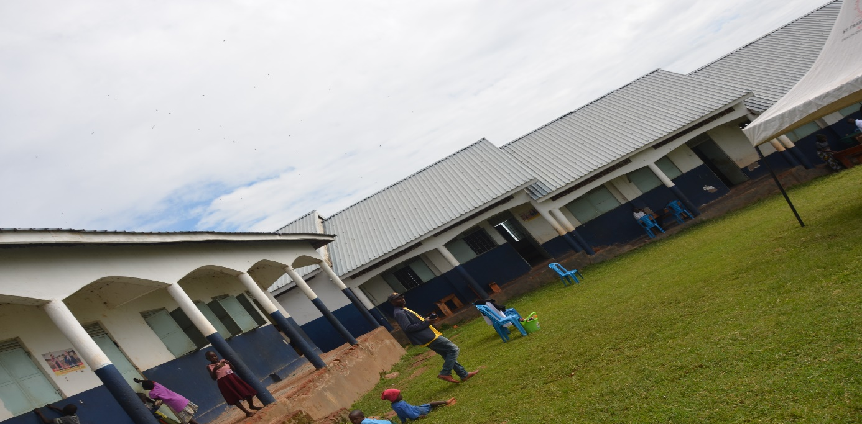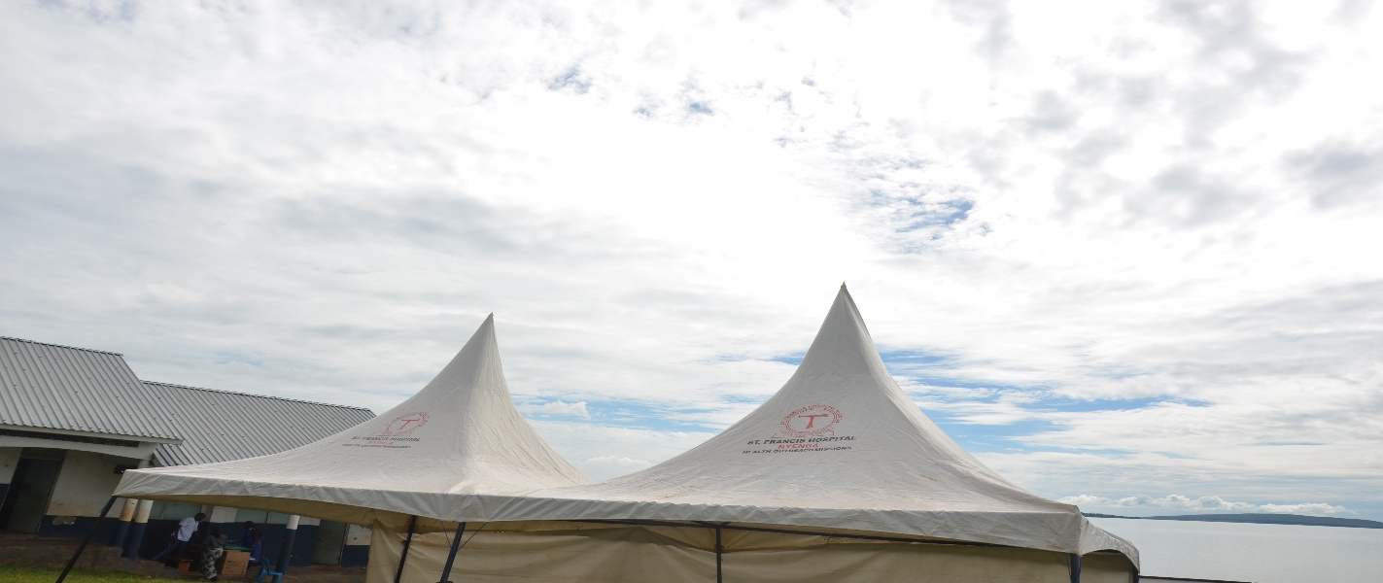

**TRIAGE**

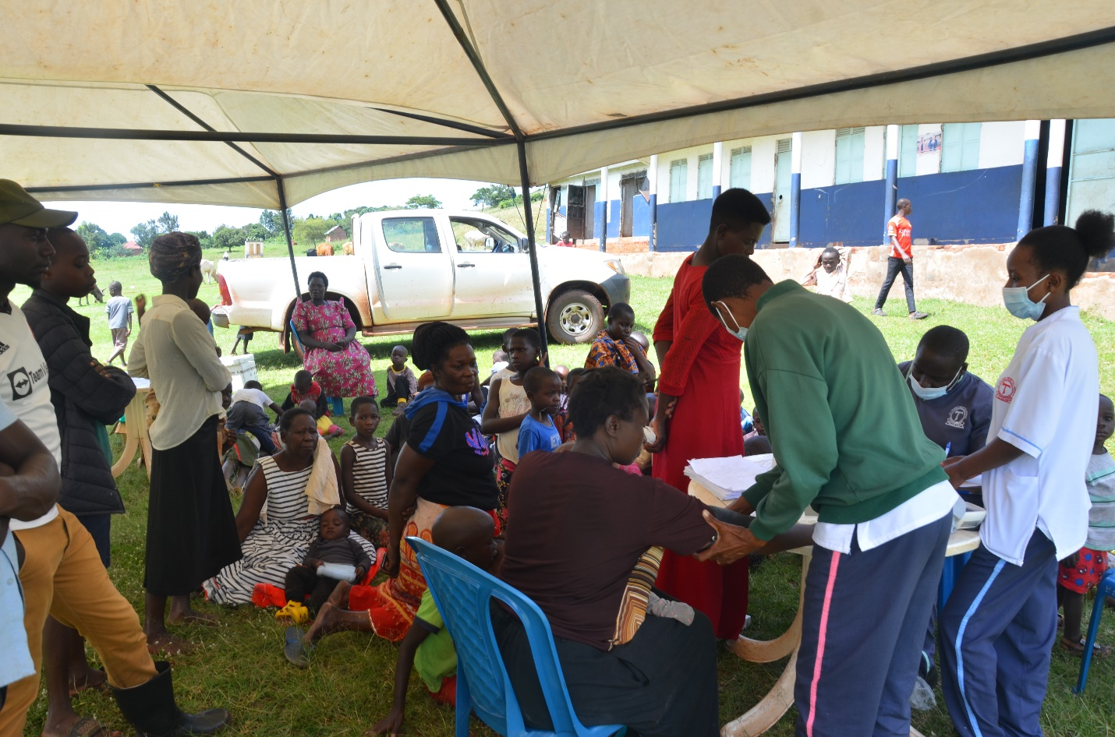

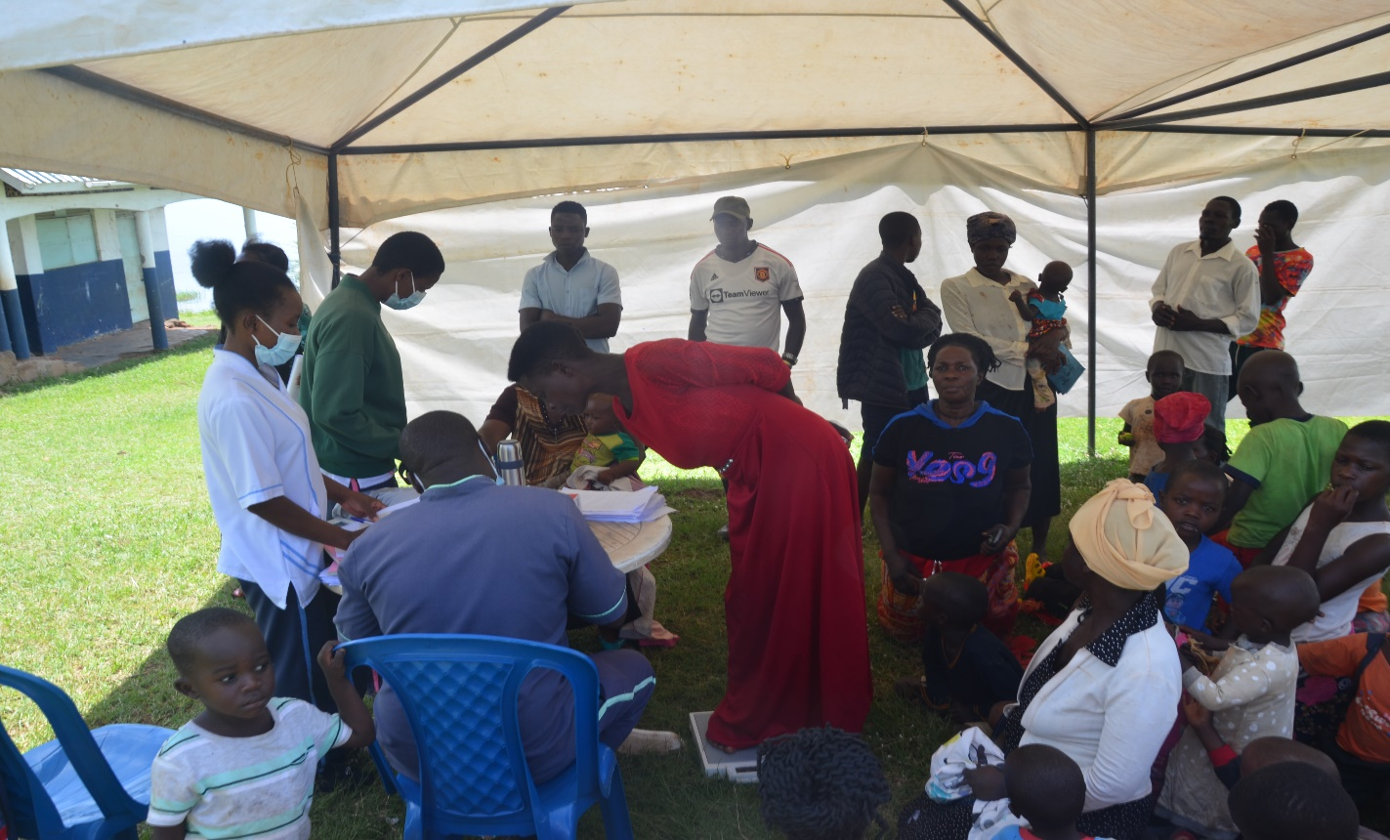

**HEALTH EDUCATION**

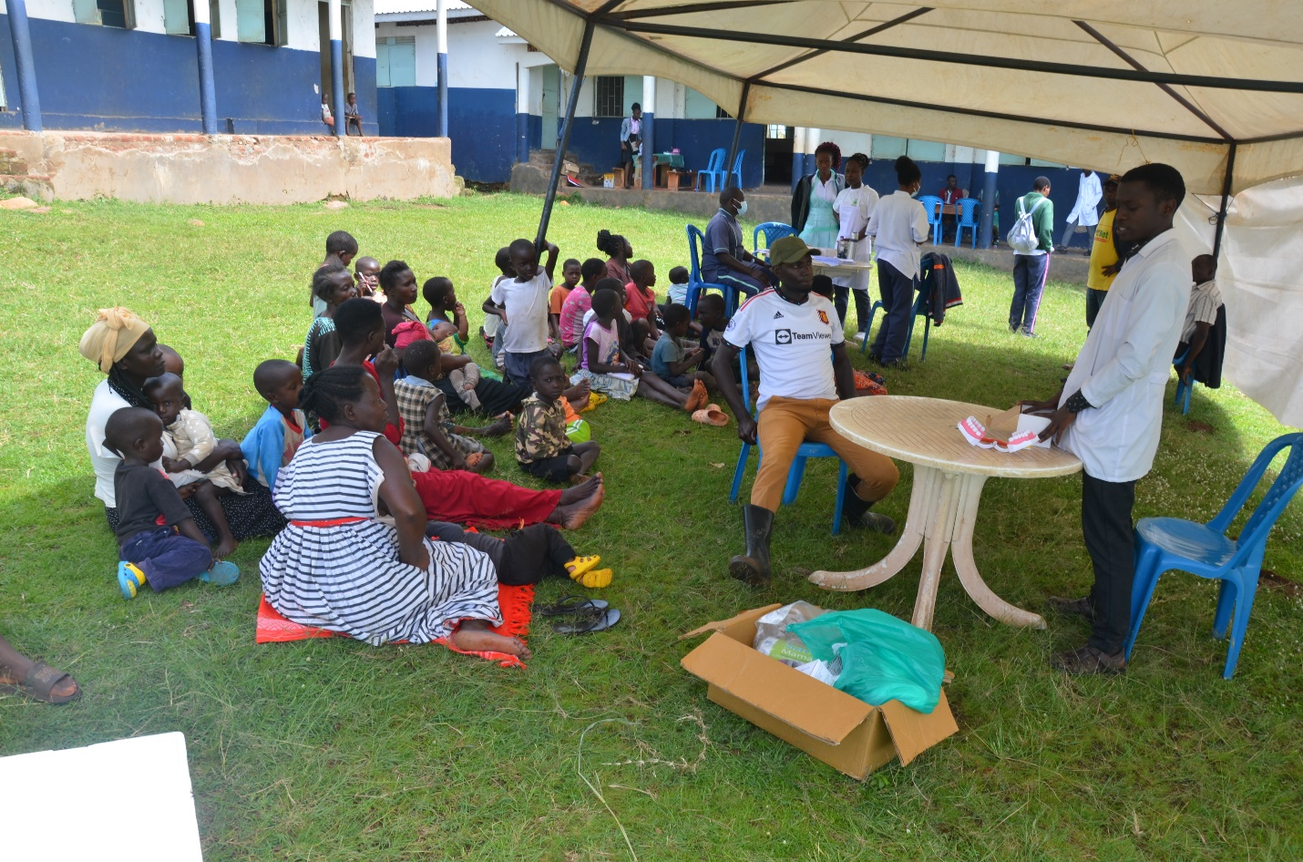

**DENTAL**

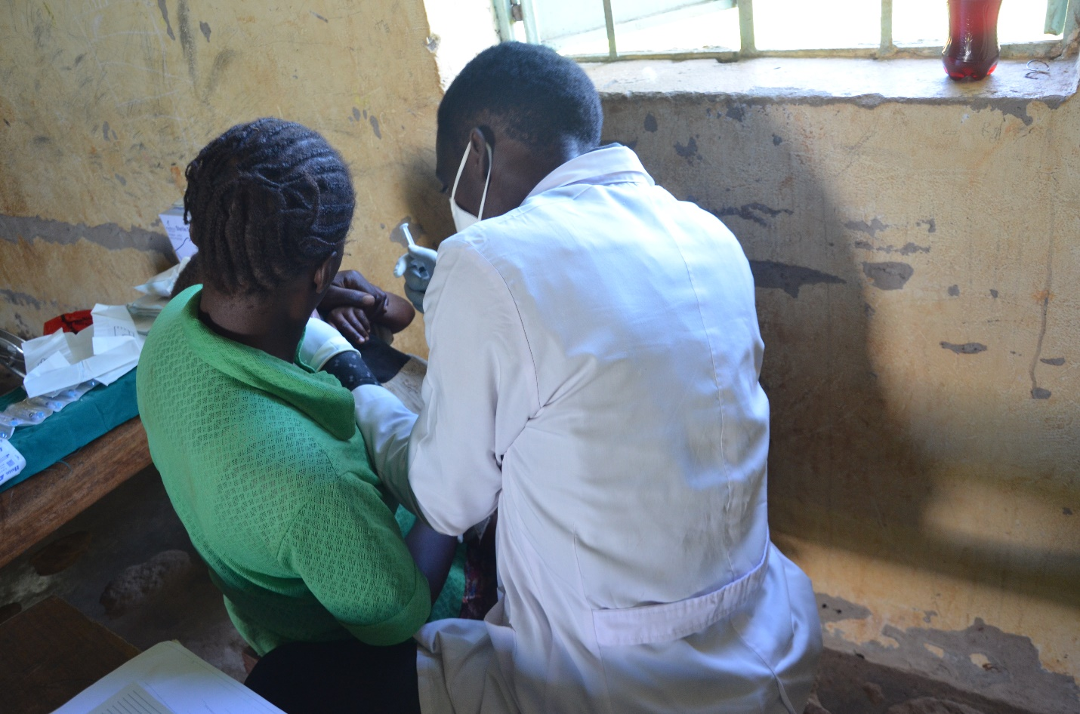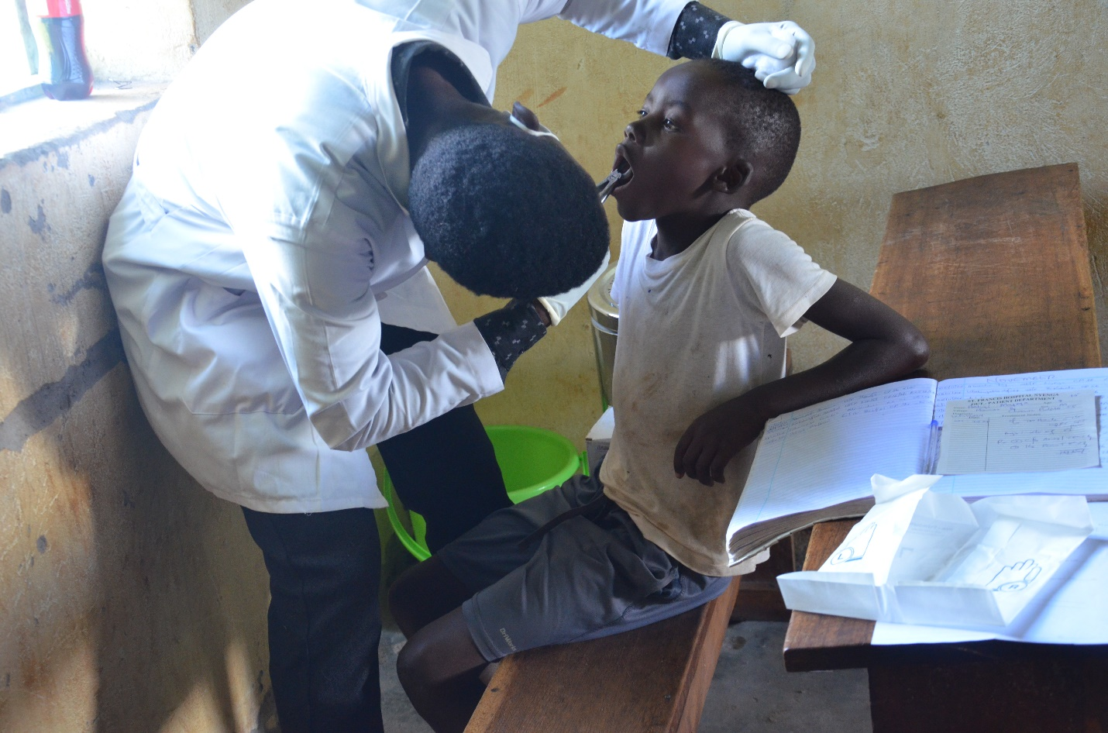

**CLINICIANS**

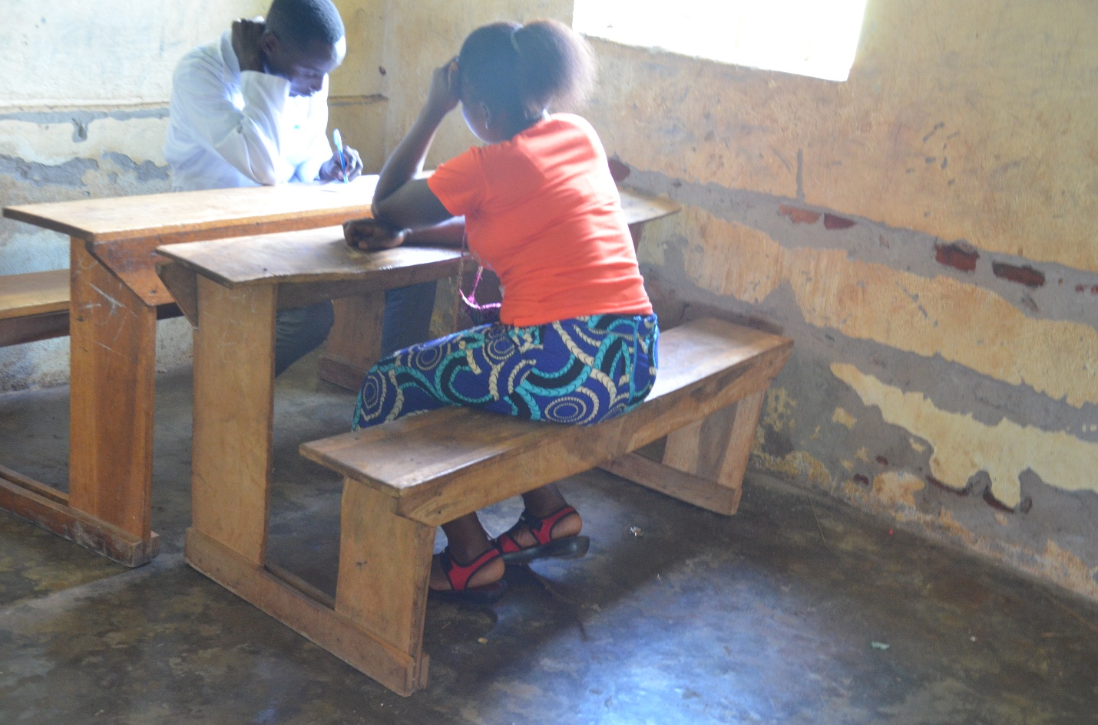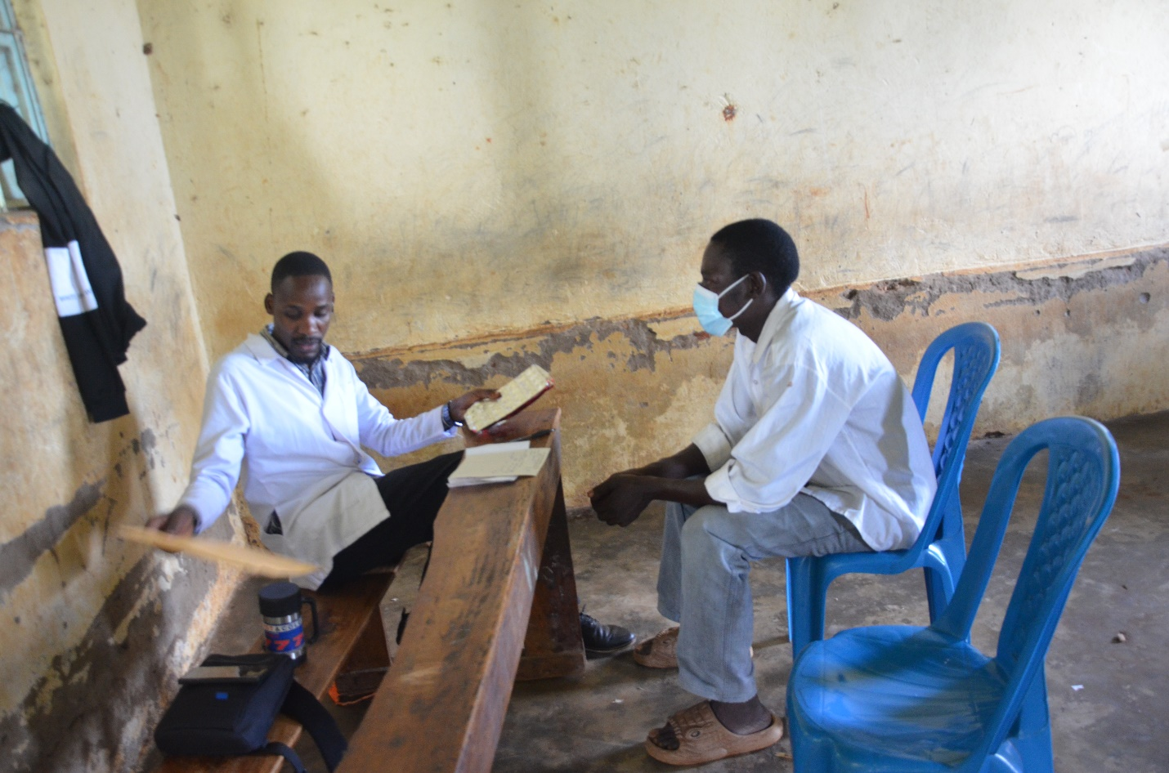

**LAB**

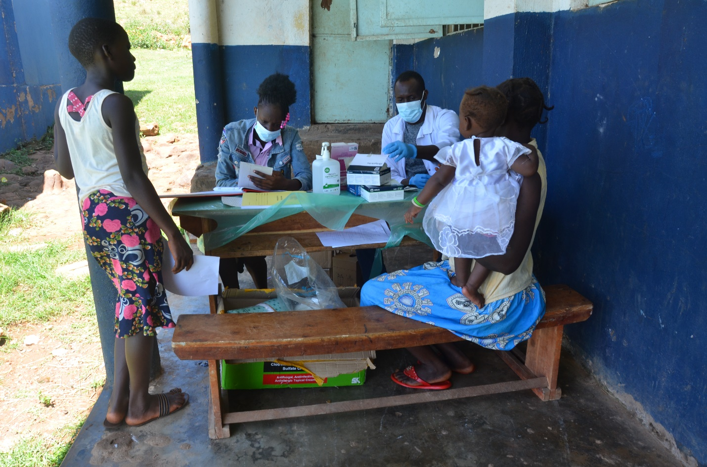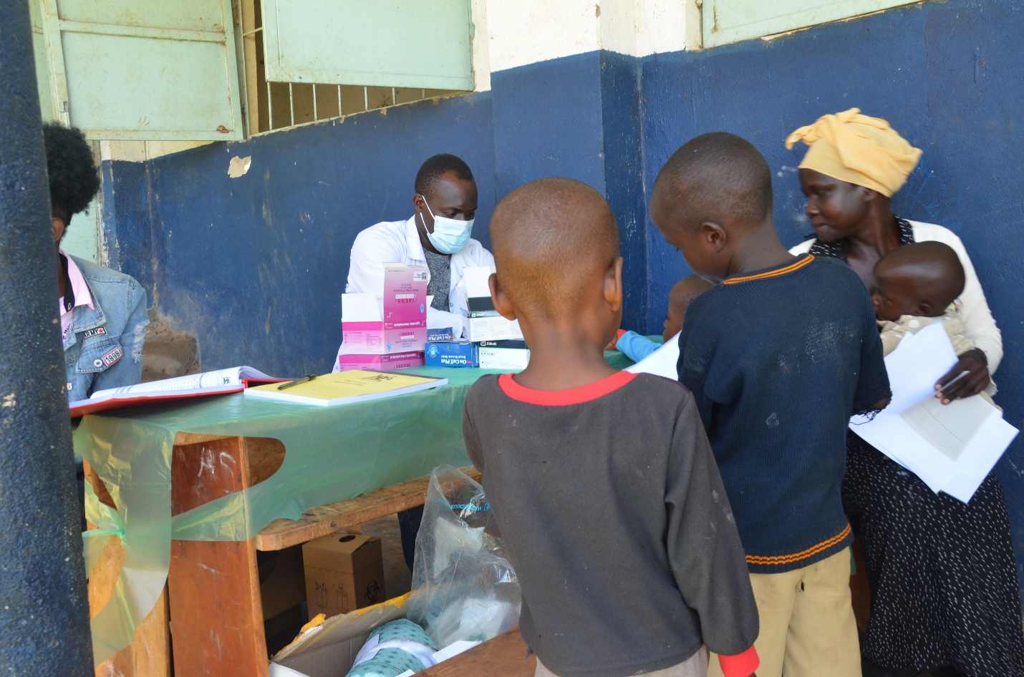

**DISPENSARY**

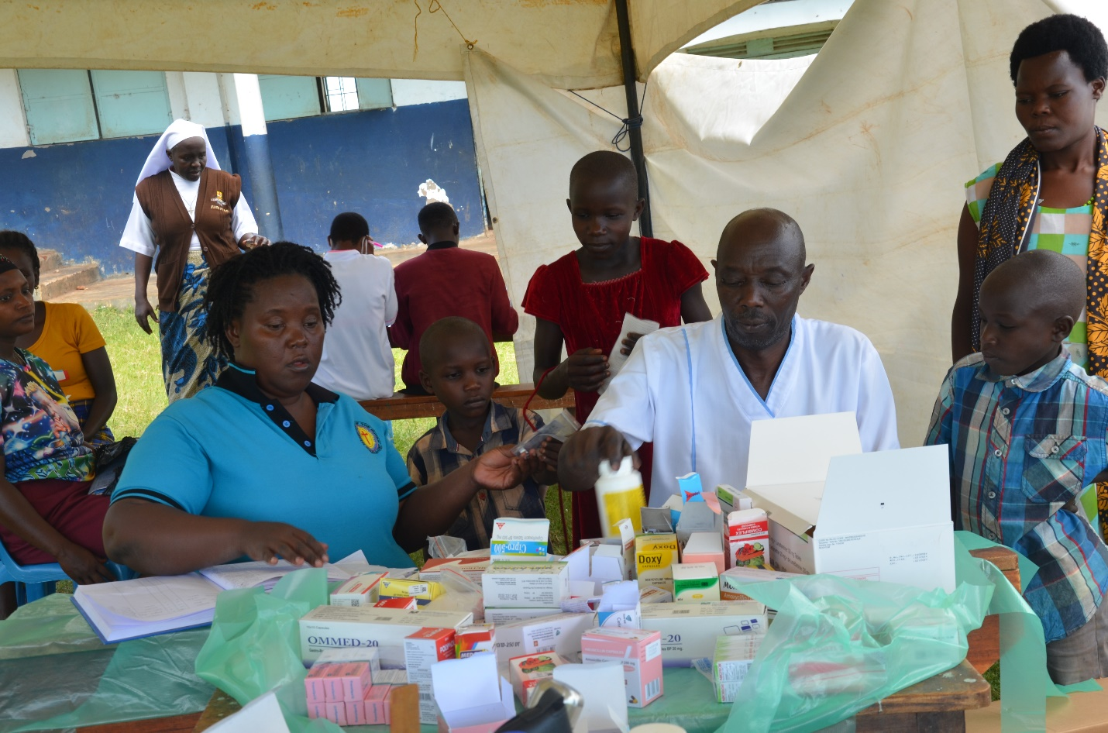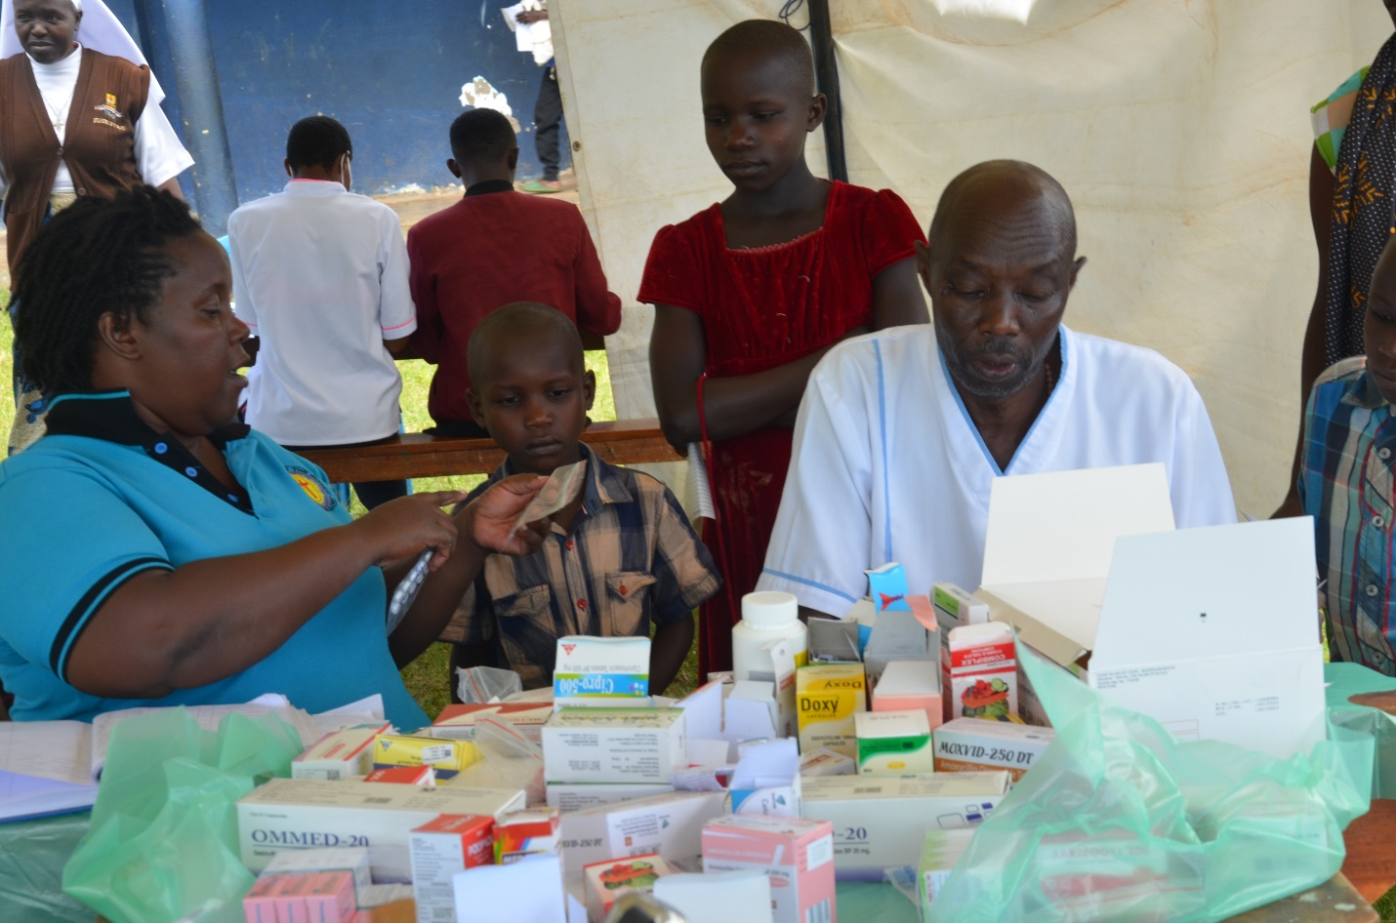

**ULTRASOUND**

